

resolut USB-in HQ Purpose and Characteristics

Resolut USB-IN HQ module is intended for installation in audio processor Resolut. for direct transfer of digital audio signal from sources with audio stream output via USB port(for instance, smartphones, carPC, head units with OP Android and etc.).

- USB version – USB 2.0
- USB-input type – USB-B
- Opportunity of connected device charging – no

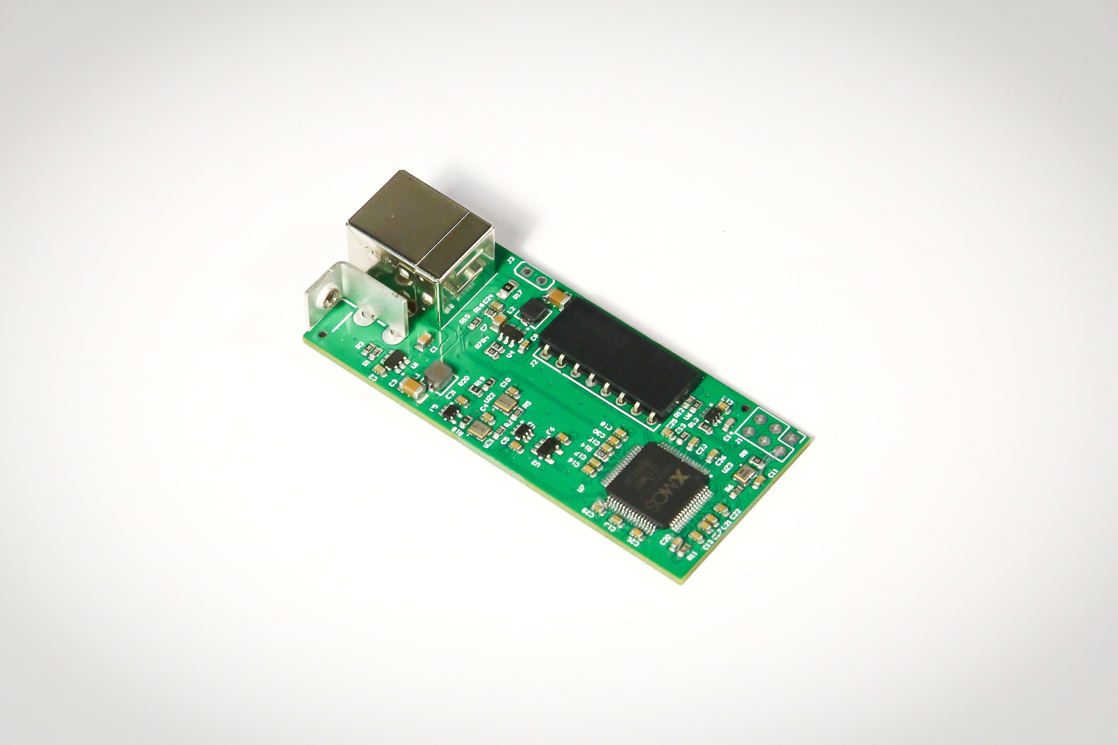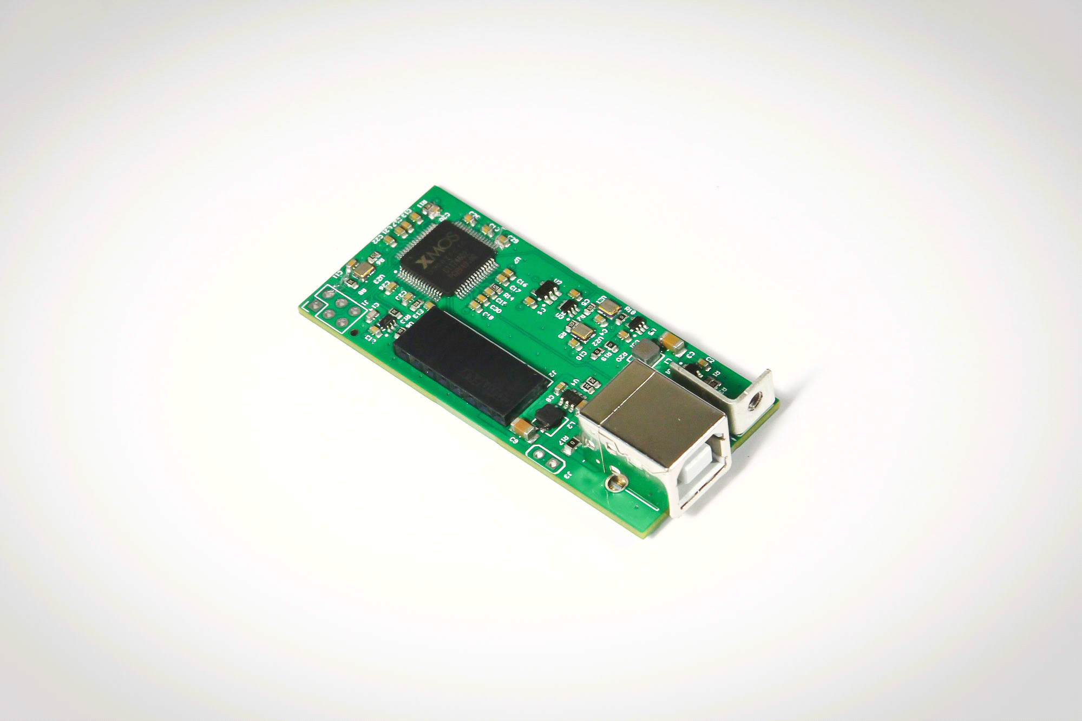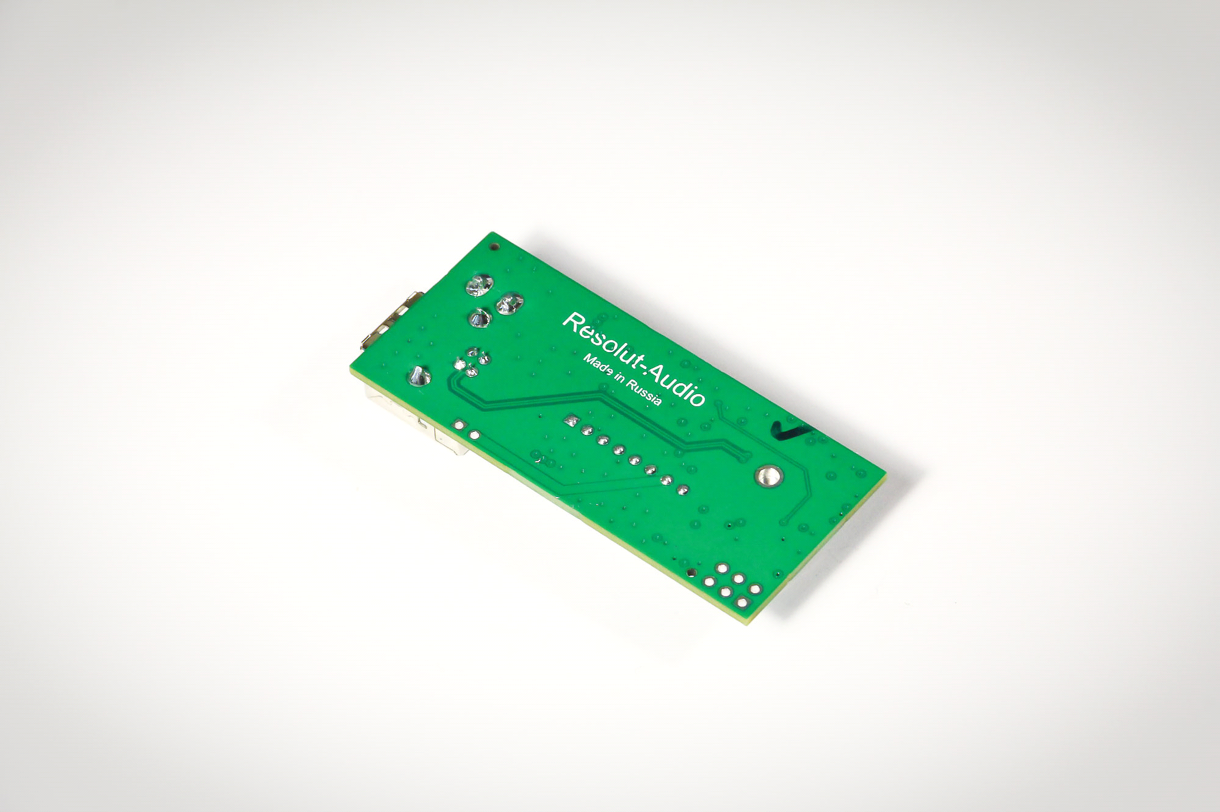

Conciliation. We are continuously improving our product therefore individual elements and details of appearance may differ from what you see on the photos..

Delivery set

- Оptional module Resolut USB-IN HQ– 1.
- Replacement panel for processor– 1.
INSTALLATION MANUAL resolut USB-in HQ module

Step 1. For installation of module turn four screws on top cover and screws on face panel. Remove cover and panel.

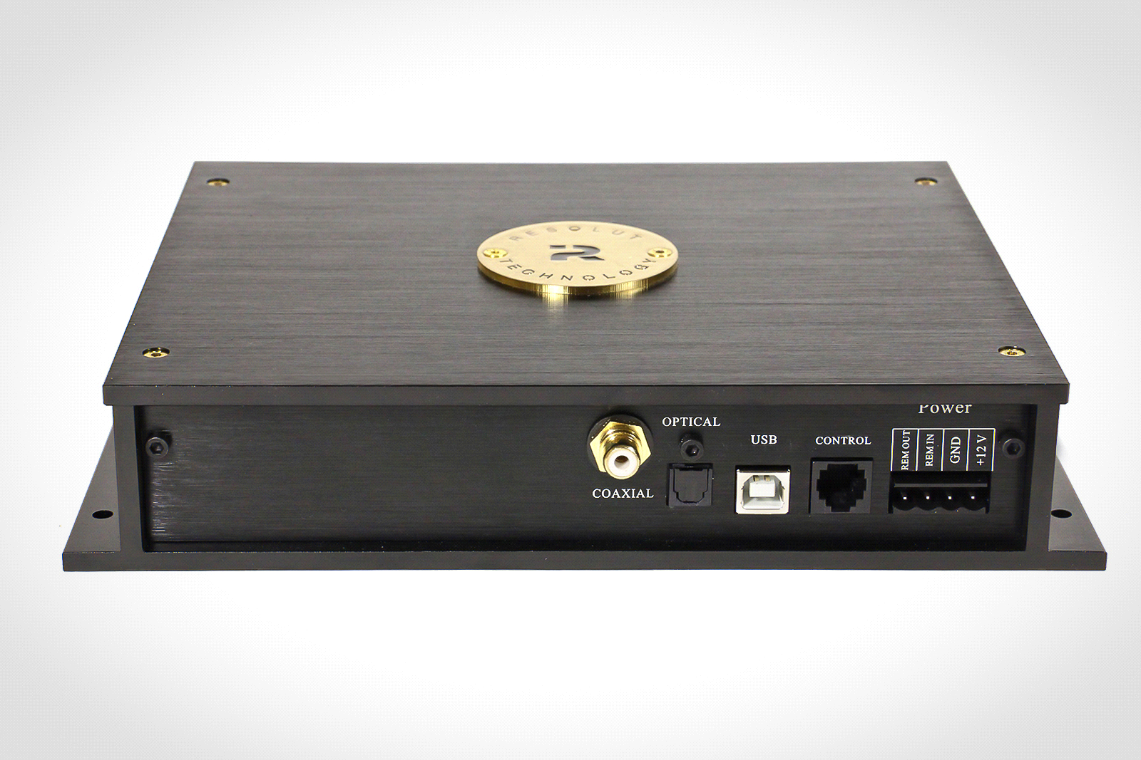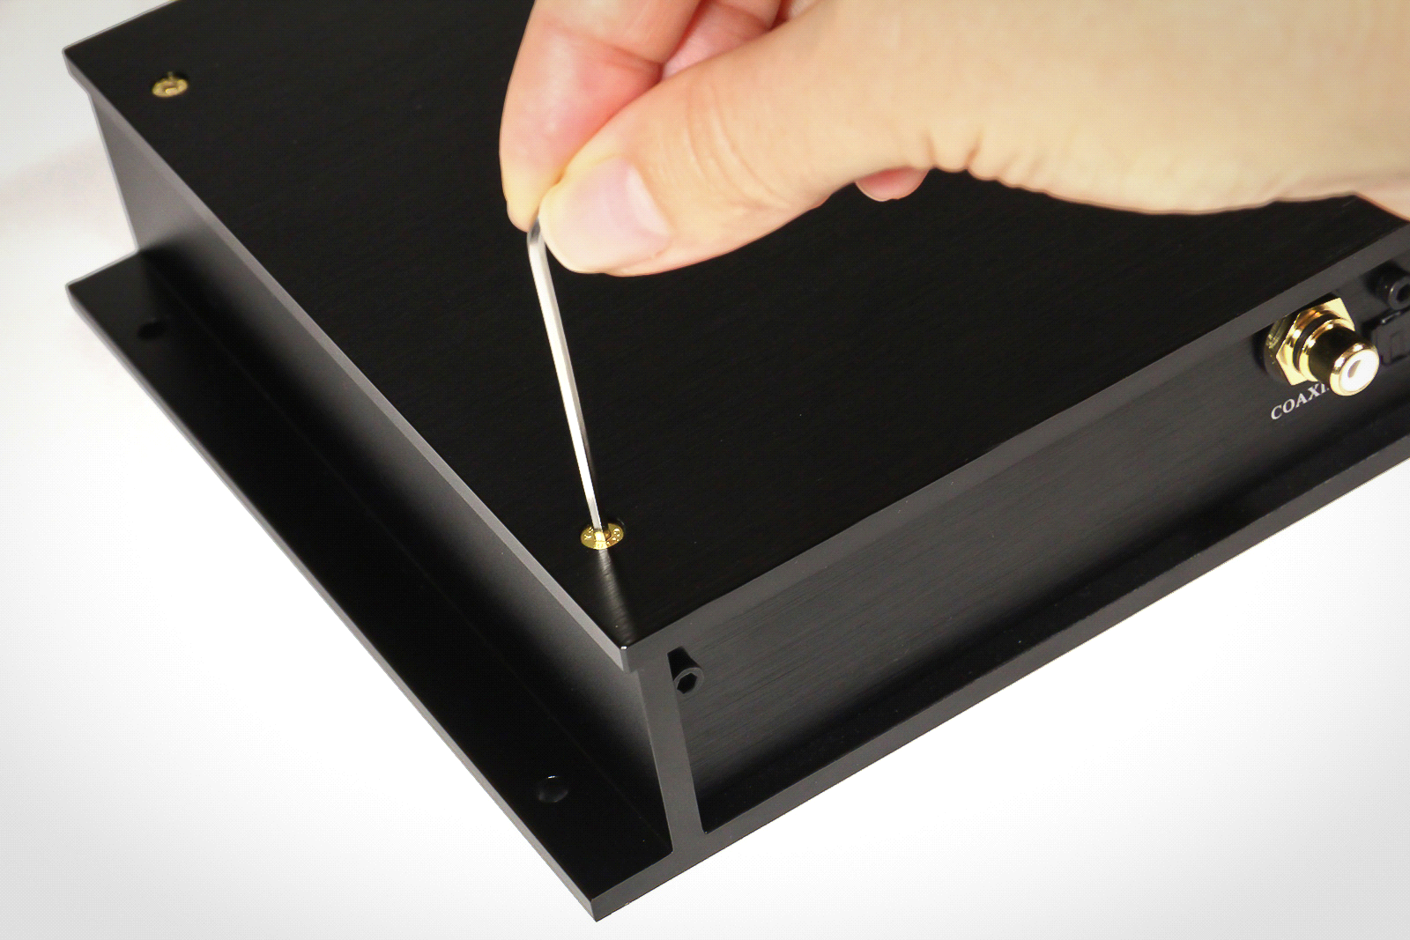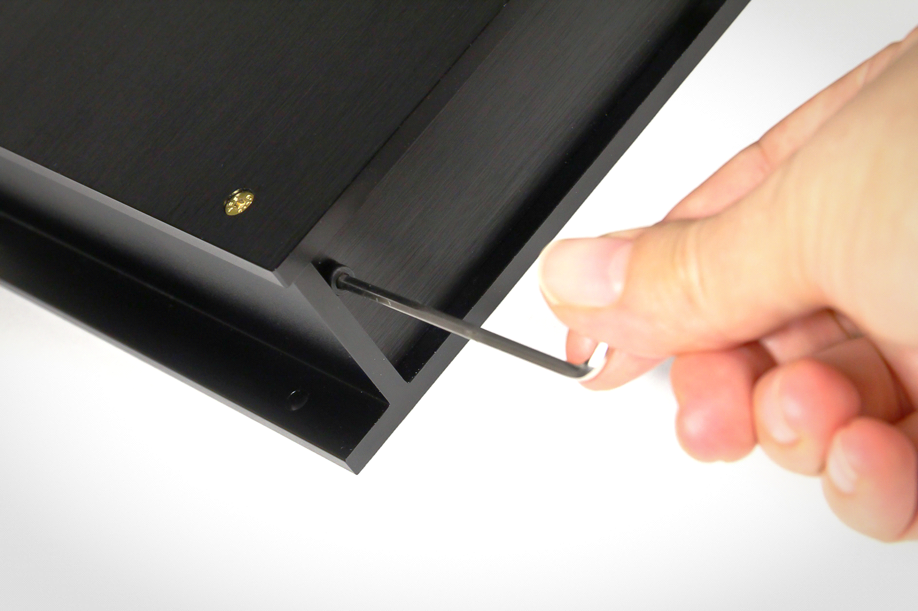

Further base panel will be changed by replacement panel from delivery set.

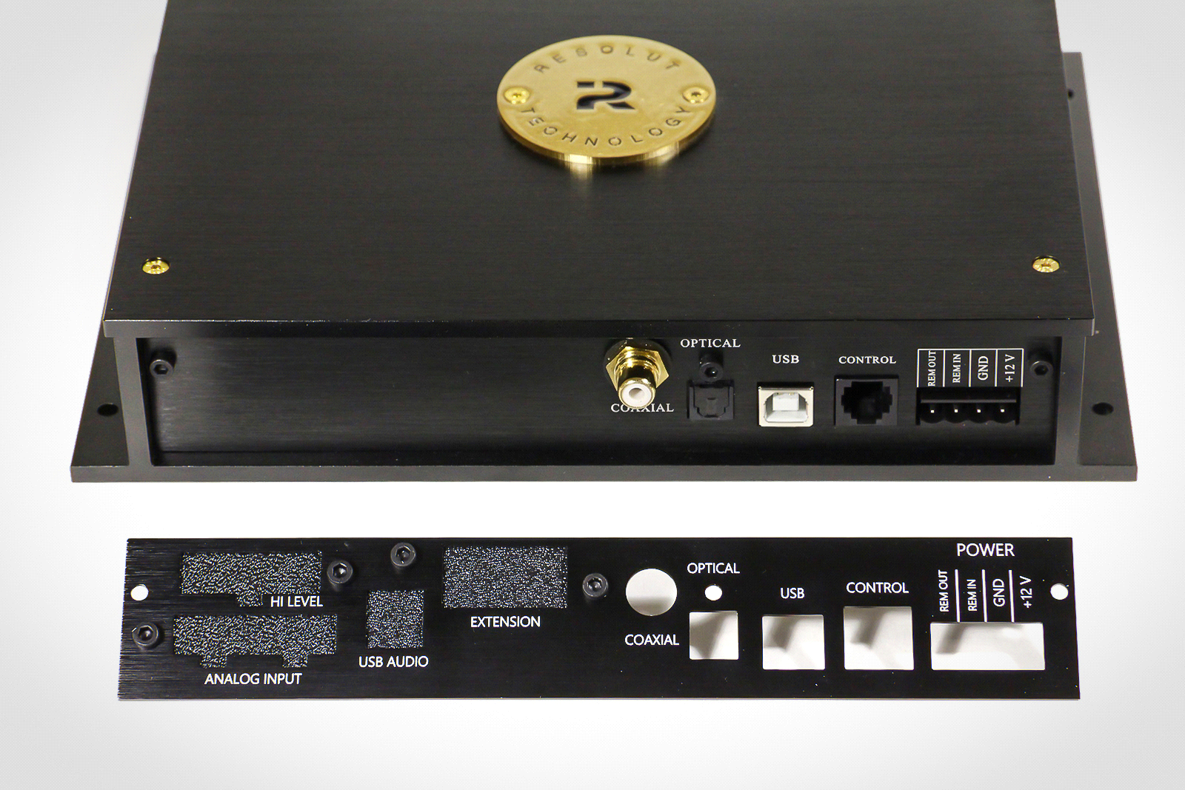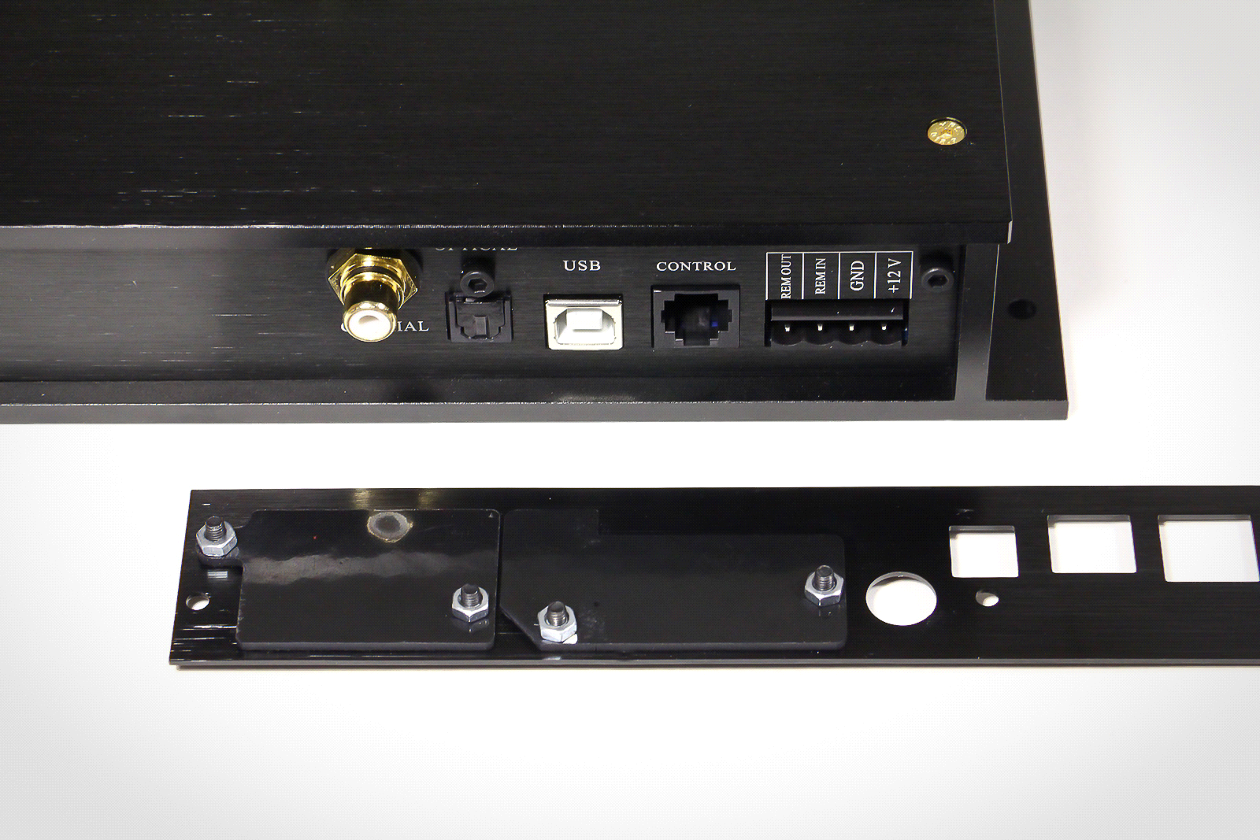

Step 2. Carefully disconnect digital coaxial input from the board. Please note order the wires are connected to board, further wires must be connected the same way. Remove connector with base panel and replace it to a new panel.
.

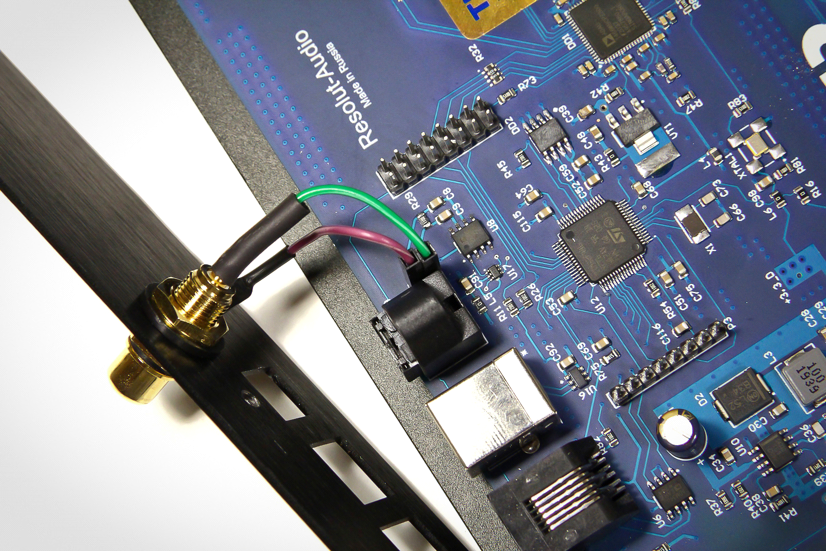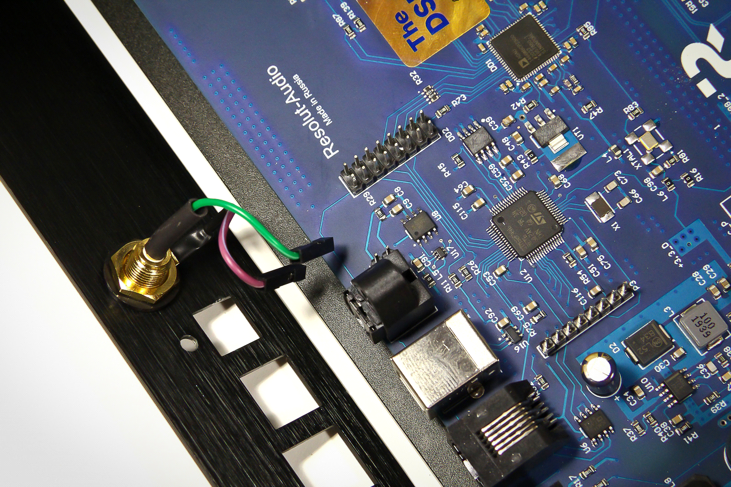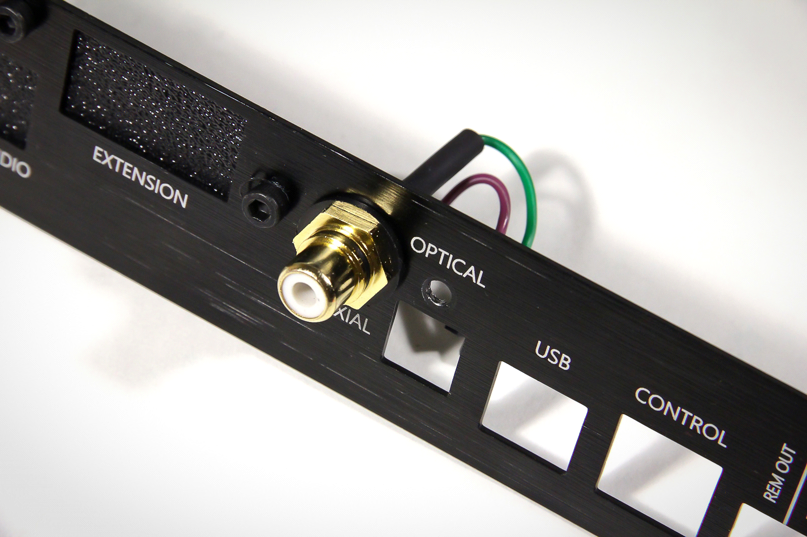

Step 3. Put Resolut USB-IN HQ module as on the photo. Make sure that connector on module are connected pin to pin to header on the board..

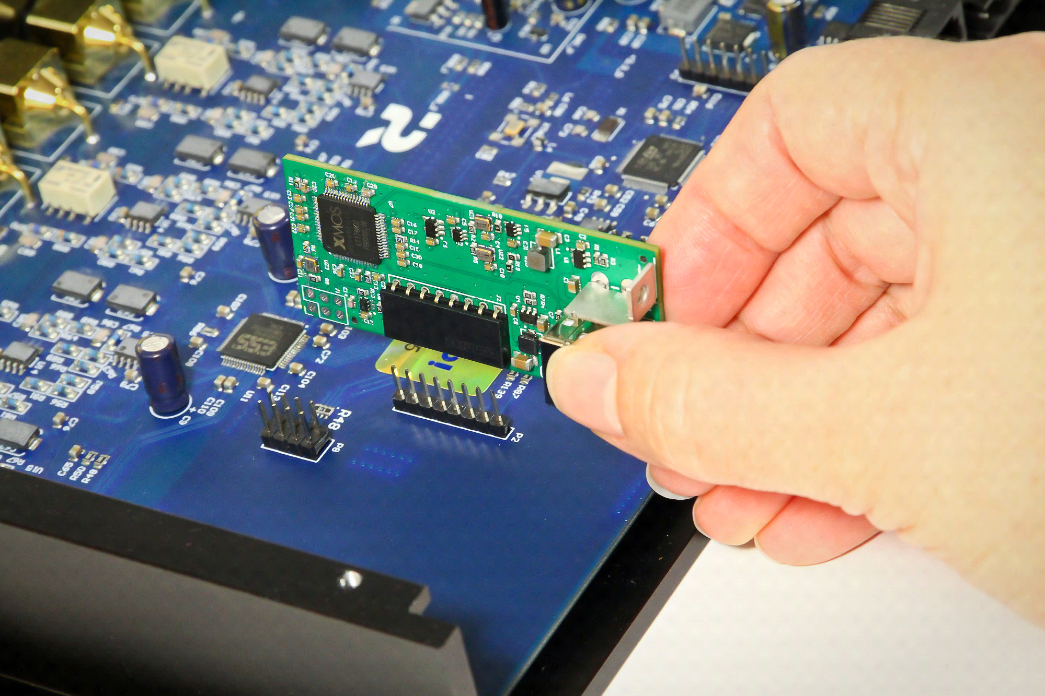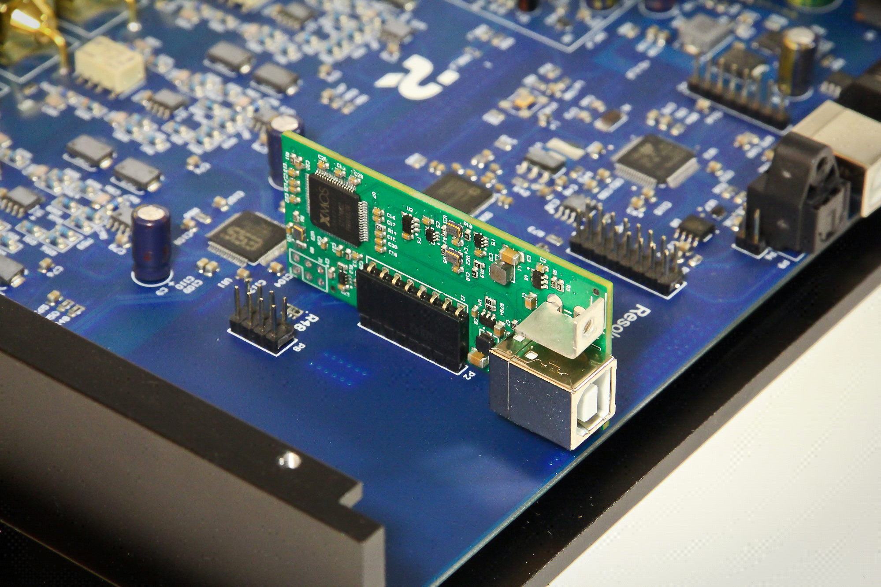

Step 4. Replacement panel has holes for additional modules, closed by plugs. Remove plug from USB AUDIO and EXTENSION and break it, while following the line. When lack of EXTENSION plug back. Fixate the replaceable panel on the board. Use base panel’s and plug’s remaining rods. Don’t forget to connect the digital coaxial input to processor's board.

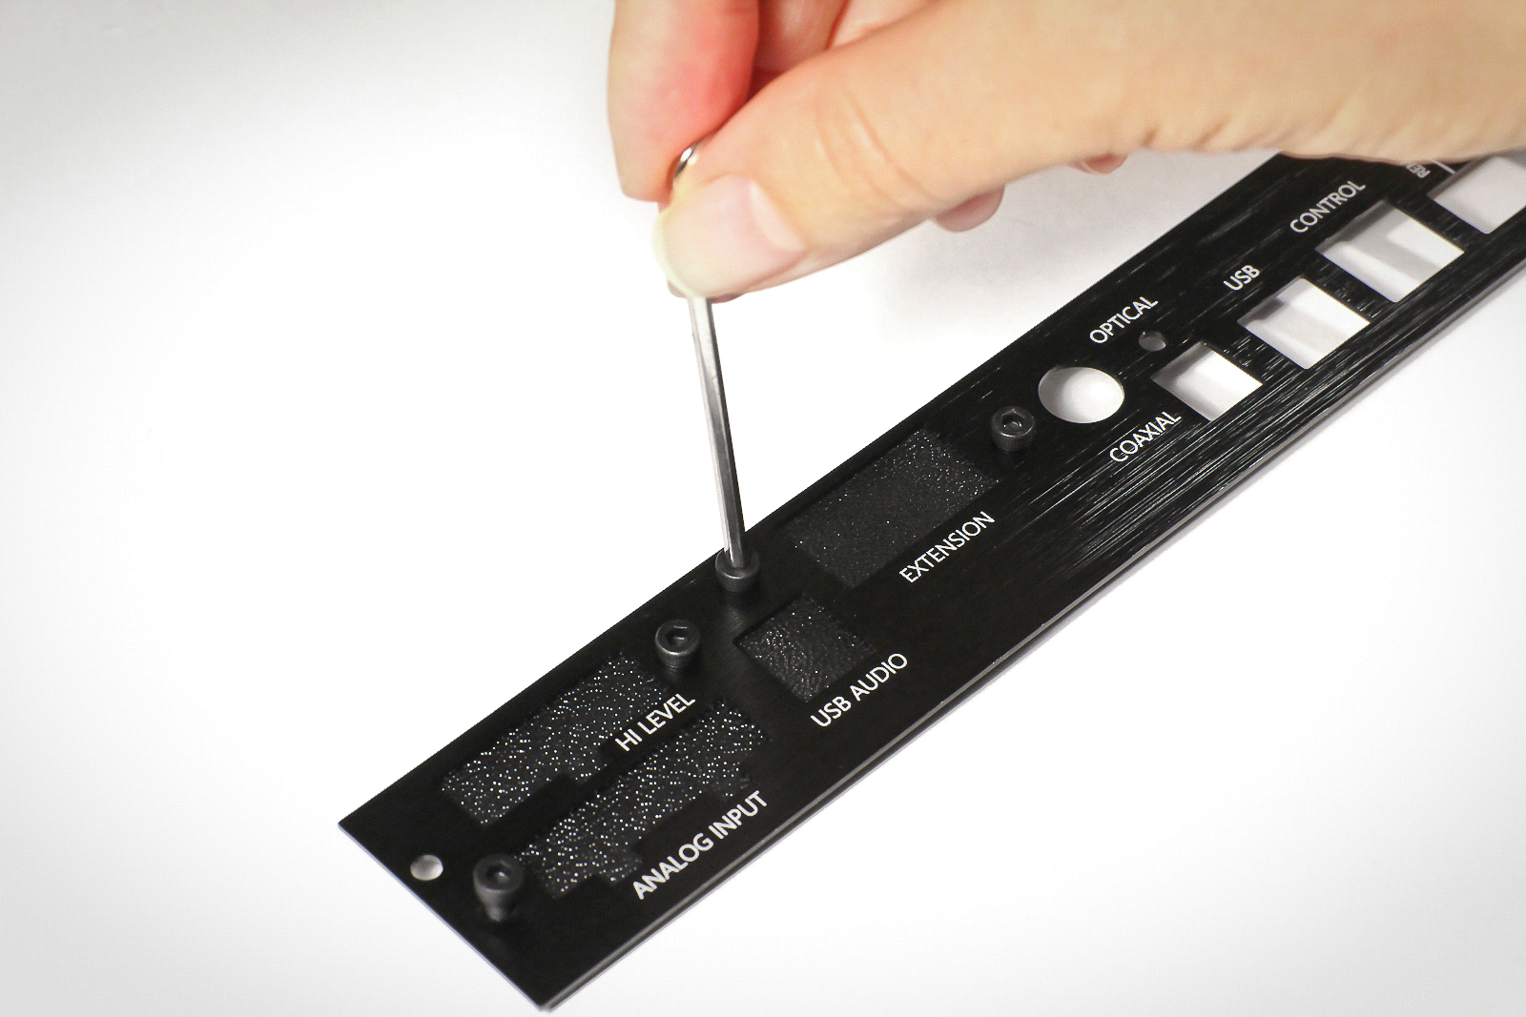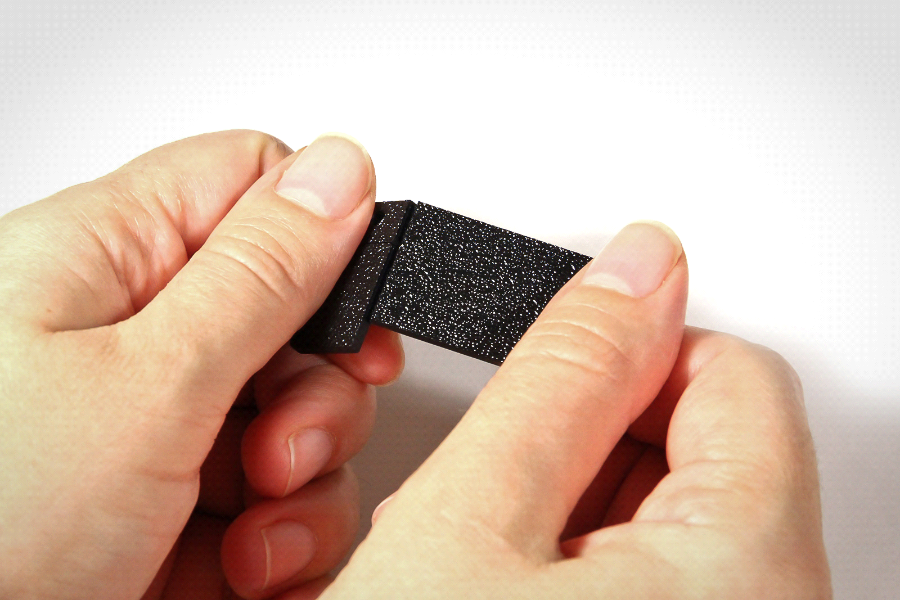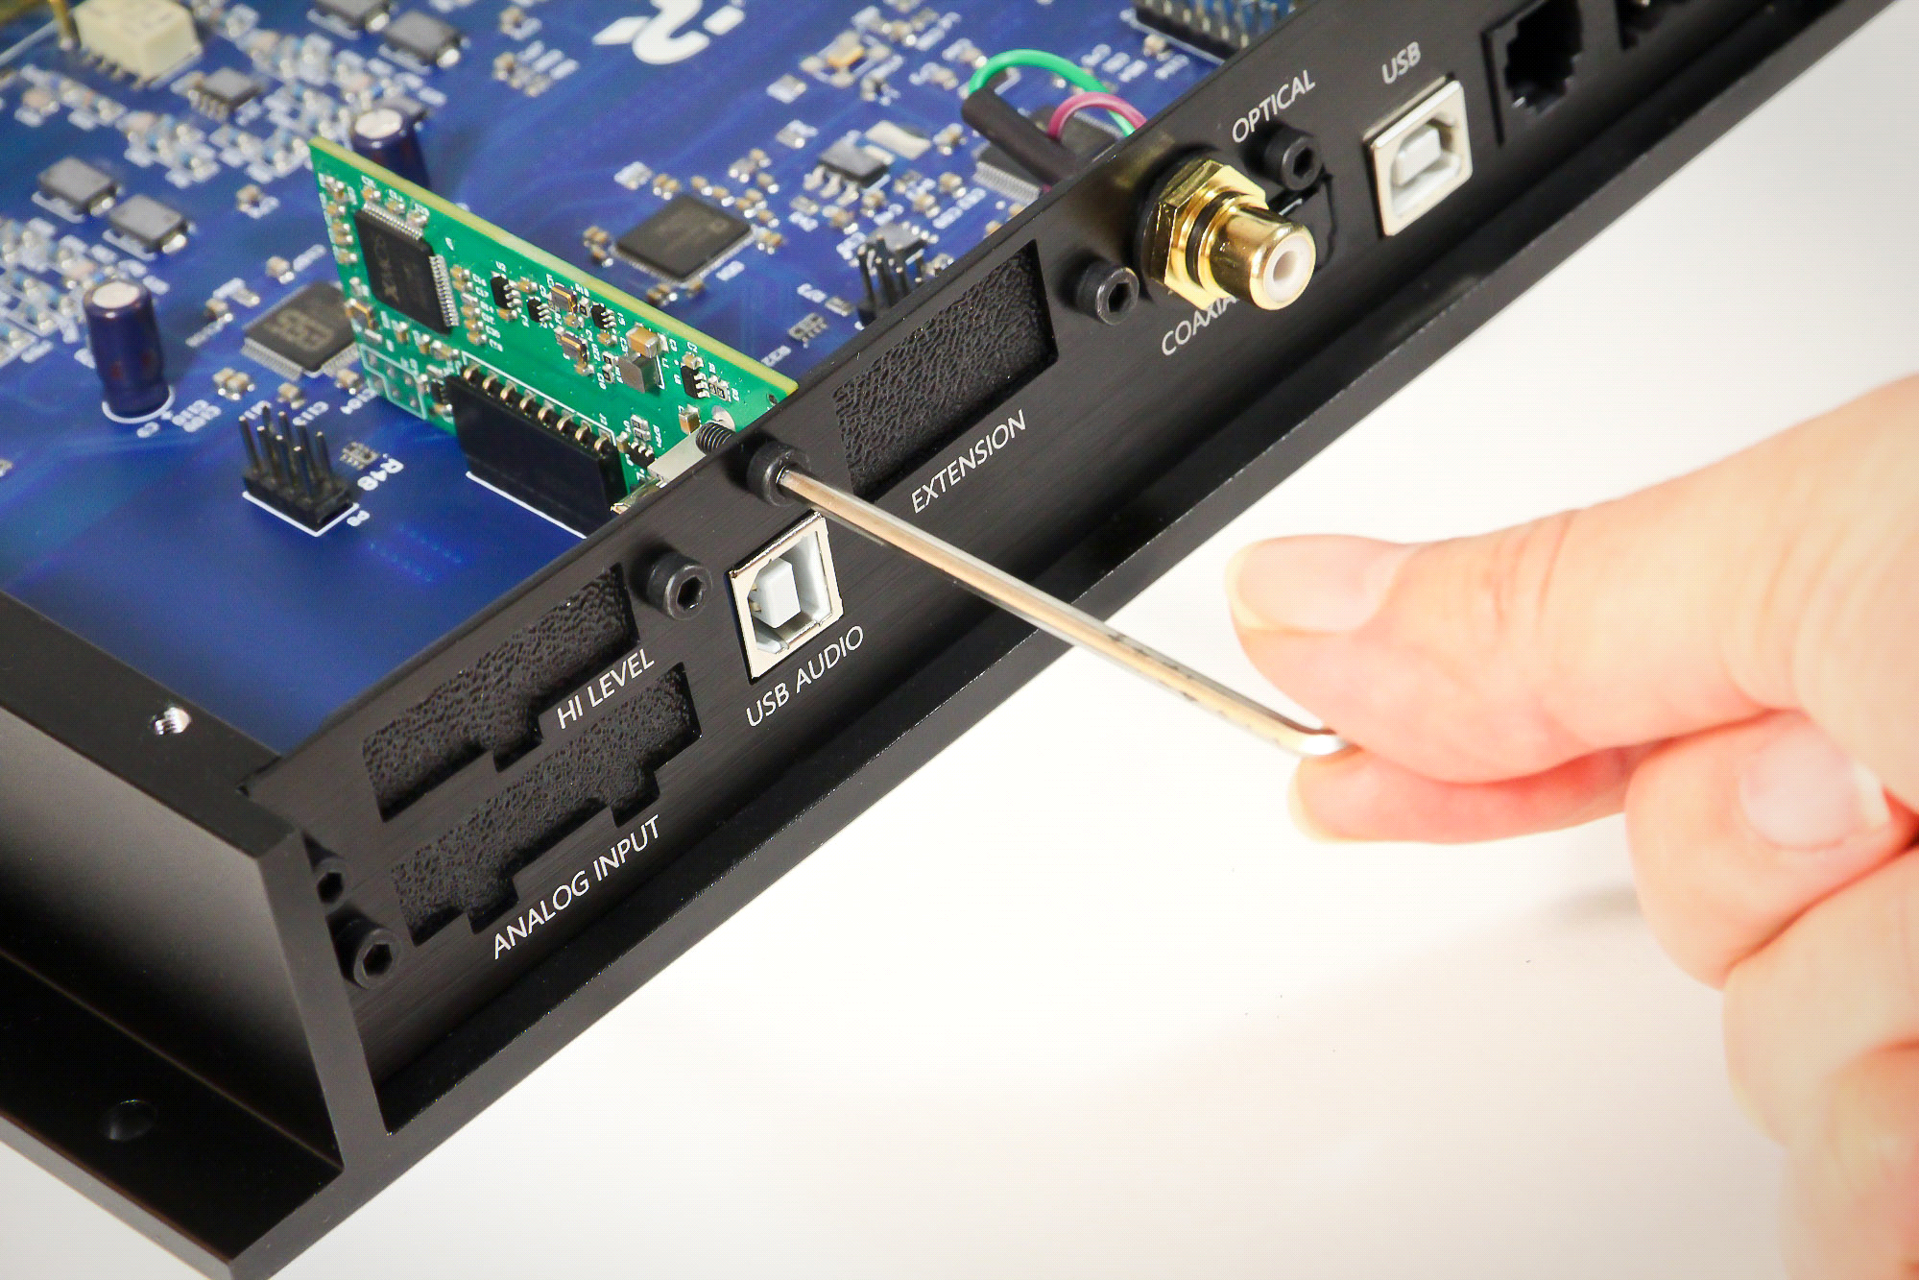

Advice. Don’t throw away removed base panel and plugs from replacement panel. If necessary to change processor's configuration by installation/removal of optional modules, you can return plugs on their places or install again base panel.

Step 5. Return the cover on corpus. After installation module looks like:

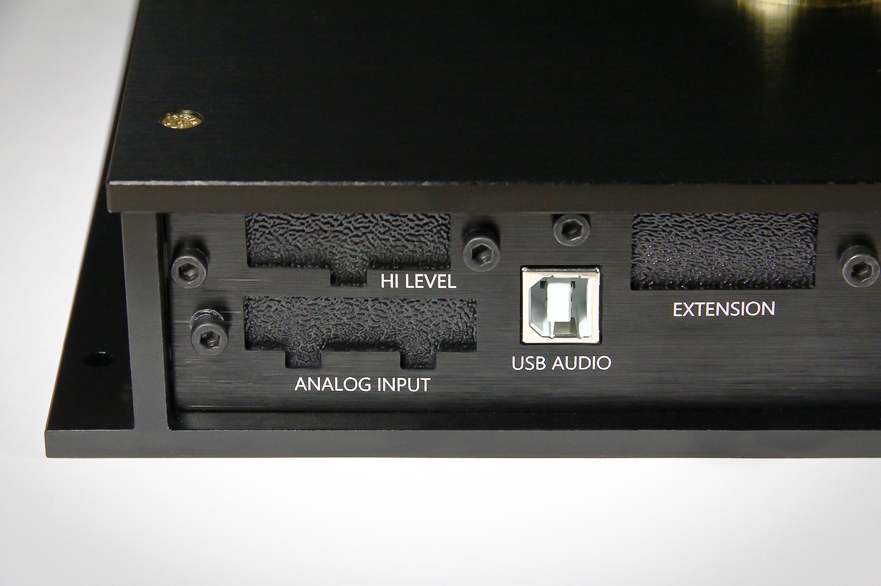

Step 6. Go to official web-site resolut-audio.ru. In tab «Downloads» you can find the latest updates of program Resolut DSP Tool, firmware and plugins for different modules. Download and install Resolut DSP Tool and file of plugin for module Resolut USB-IN HQ

Step 7. Connect the processor to PC, open it and run Resolut DSP Tool. Be sure that processor connection is normal. Following the manual of software update (like described in "User manual"), install to processor suitable plugin for working with Resolut USB-IN HQ module.

Congratulations! You processor Resolut now is equipped with USB-Audio input!

